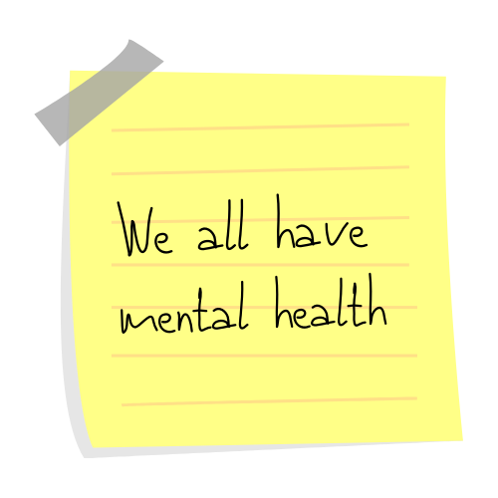
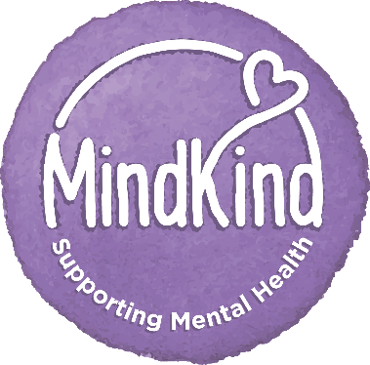

- This Wellbeing Action Plan belongs to you. You don’t have to share it, or any of the information it contains unless you wish to.

- We all have mental health, anyone can use this form, along with the supporting information online, to help them look after their mental health and wellbeing.

- This Wellbeing Action Plan will help you identify what keeps you well, what causes you to become unwell and how you can look after your mental health and wellbeing both in and out of work.

- Everything you need to know about the MindKind Wellbeing Action Plan is available on the intranet.

- You’ll get the most out of this Wellbeing Action Plan if you update it regularly.
My Name: | <enter name here>
Date Wellbeing Action Plan created: | <enter date here>
Date updated: | <enter date here>

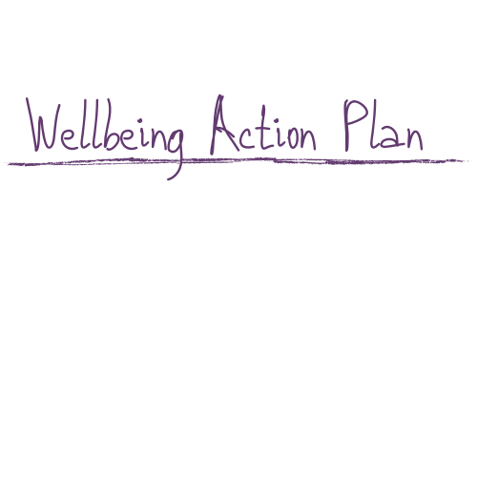

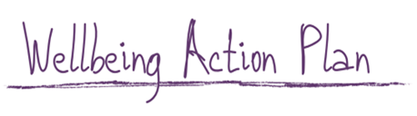
Awareness

- What does good mental health look like for you?
Think about yourself when your mental wellbeing is good. List how you feel and what you do in the box below.

e.g. I feel confident and motivated, I get up early, I sleep well, I easily solve problems and make decisions.

When my mental health is good I:

- <enter text here>
- <enter text here>
- <enter text here>
- <enter text here>
- <enter text here>

- What helps you keep your mental wellbeing positive?
List the things that help you in the box below.

e.g. Taking a lunch break away from my desk, getting some exercise, meeting with friends, regular positive feedback from colleagues.

These things help me keep my mental health positive:

- <enter text here>
- <enter text here>
- <enter text here>
- <enter text here>
- <enter text here>

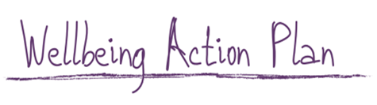
- What do you look like when your mental wellbeing is not positive?
Think about yourself when your mental wellbeing is not positive. What are the early warning signs? List how you feel and what you do in the box below.

e.g. I find it difficult to make decisions, I struggle to prioritise, I find it harder to concentrate, I feel drowsy, I feel irritable with family and friends, I get headaches.

When my mental health is not positive I:

- <enter text here>
- <enter text here>
- <enter text here>
- <enter text here>
- <enter text here>

- What might others notice about you when your mental wellbeing is not positive?
List what others might notice about you when you’re mental health is not positive in the box below, include any early warning signs that others can look out for.

e.g. Irritable, change in my routine, not smiling.

When my mental health is not positive, those around me may notice that I:

- <enter text here>
- <enter text here>
- <enter text here>
- <enter text here>
- <enter text here>

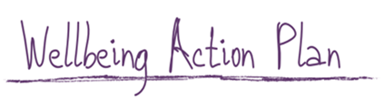
Positive Actions

- What can you do if you notice your mental wellbeing is not positive?
List the things you can do in the box below

e.g. Talk to someone you trust, think about my sleep routine, make sure I am eating well.

When my mental health is not positive, I can help myself by:

- <enter text here>
- <enter text here>
- <enter text here>
- <enter text here>
- <enter text here>

- If others notice your mental wellbeing is not positive, what could they do?
List the things other could do in the box below

e.g. Talk to you discreetly about it, give you space, support you with your workload.

When my mental health is not positive, other can help me by:

- <enter text here>
- <enter text here>
- <enter text here>
- <enter text here>
- <enter text here>

- Are there any situations that can have a negative impact on your mental wellbeing?
Think about the situations that can have a negative impact on your mental wellbeing and list them in the box below

e.g. Agile working leading to isolation, when pressure is high, near a project deadline.

These situations can negatively impact on my mental wellbeing:

- <enter text here>
- <enter text here>
- <enter text here>
- <enter text here>
- <enter text here>

- What can you do to limit or prevent the negative impact of the situations you’ve listed in the box above?
Think about the situations you’ve listed above and the ways you can prevent or limit the impact of them.

e.g, Regular catch ups, agile working, planning / preparing ahead, asking for help.

I can prevent or limit situations having a negative impact on my mental wellbeing by:

- <enter text here>
- <enter text here>
- <enter text here>
- <enter text here>
- <enter text here>

- What could others do to help in these situations? Is there anything work might be able to do to support you?
Think about the situations you’ve listed above and list the ways work could support you in the box below.

e.g. You might like to take a break from your desk and go for a short walk, opportunities to discuss priorities and support.

Work can support me by:

- <enter text here>
- <enter text here>
- <enter text here>
- <enter text here>
- <enter text here>
- <enter text here>

- How can you help others better understand your needs, experiences and what they can do to support you?
You can use this Wellbeing Action Plan to help you have a positive conversation with your manager, another colleague or a family member.
Only share what you feel comfortable sharing. This Wellbeing Action Plan belongs to you. You can share parts of it, all of it or none of it - it’s up to you.
List the people you will have a conversation with about your mental health in the box below:

- <enter text here>
- <enter text here>
- <enter text here>
- <enter text here>
- <enter text here>

10Tips for staying well

- Build a network of support by developing good relationships your colleagues. | - Talk to someone you trust (at work or outside) about what upsets you or makes you feel stressed.
- Ask for help. | - Be assertive – say no if you can’t take on extra demands.
- Be realistic – you don’t have to be perfect all the time. | - Feeling overwhelmed? Take a deep breath and try to get away from your desk or situation for a few minutes.
- Write a list of what needs to be done; it only takes a few minutes and can help you get things in perspective. It’s also satisfying to tick items off when they’re done. | - Try to take a walk or get some fresh air during the day. Exercise and daylight are good for your mental health as well as physical health.
- Work regular hours and take the breaks and holidays you’re entitled to. If things are getting too much, book a day off or have a long weekend if you can do so. | - Work regular hours and take the breaks and holidays you’re entitled to. If things are getting too much, book a day off or have a long weekend if you can.

More information and support:

- MindKind – Information, tools and guidance to help you look after yourself and those around you.

- Thinkwell - Friendly, confidential help to keep your mental health on track.

- Every Mind Matters – NHS tools and resources for mental health

- Action for Happiness - Practical action, drawing on the latest scientific research

Need Urgent help?

If you need urgent help or feel unable to keep yourself safe please contact one of the following immediately:

- Phone your GP
- call NHS 111
- Visit A&E or call 999
Call 116 123 (free to call) to talk to someone at the Samaritans at any time of day or night.

The WAP is inspired by Mary Ellen Copeland’s Wellness Recovery Action Plan® (WRAP®): an evidence-based system used worldwide by people to manage their mental health.

